**Overview:**

Students work individually to understand and establish the specifications for a PC dedicated to a specific task or function. (The specific task or function will be assigned to the student from the list below.) The function and features of various hardware components are researched to develop a general understanding. Specific components and features are then selected based on appropriate need for the assigned task or function. The final product is a brochure that will be shared with other classmates during a tradeshow event.

**Objectives:**

* Use correct terminology to describe computer hardware, speed measurements, and size

measurements

* Describe the functions of the internal components of a computer
* Describe the functions of common computer peripheral devices
* Assess user computing needs and select appropriate hardware components for different

situations

**Getting Started:**

1. You will be required to design a “dream machine” personal computer (PC) for one of the tasks assigned to you from the list below.
2. To get started, develop a general understanding of what will be important features and what will be less important features of our dream machine. Consider the following:
   1. Operating system software
   2. Special application software
   3. Processor & motherboard speed
   4. Main memory speed and size
   5. Secondary storage speed and size
   6. Graphics and display speed and resolution
   7. External devices (e.g. keyboard, pointing devices, joysticks, etc.)
   8. Network connectivity
   9. Power and data backup
   10. Printers, scanners, and similar equipment
   11. Portability and durability
   12. Budget (cost) considerations

Specific Tasks & Functions

1. ***Game Computer***: Dedicated to playing PC games in a home environment
2. **Photo Editing & Organization**: Dedicated to editing and producing photographs and images in a home or professional environment
3. ***Business Office Computer***: Dedicated to producing documents and presentations and communicating with other people in a professional office environment
4. ***Student Home Computer***: Dedicated to completing homework, paying bills, communicating with friends and other similar tasks in a home environment
5. ***Factory Floor Computer***: Dedicated to reading documents, filling in forms, processing orders, etc. in a factory or warehouse environment.
6. ***Media Production and Streaming Computer***: Dedicated to production and distribution of video and/or music media in a semi-professional environment
7. ***Web Surfing Computer***: Dedicated to surfing the web, streaming media, and communicating through on-line services in a home environment

**Level 1: Processor & Memory**

1. Research and summarize the main features and function of a CPU processor chip. Consider the following:
   1. Physical packaging shape and size
   2. Processing speed and power
   3. Memory speed and size
2. Research and summarize the history of how a CPU processor chip has changed over the years. Consider the following:
   1. Typical processor speed, size, model numbers in the early 1990’s
   2. Typical processor speed, size, model numbers in the early 2000’s
   3. Typical processor speed, size, model numbers in the current time
3. Research and summarize the main features of motherboards. Consider the following:
   1. Physical packaging shape and size
   2. Speed and size
4. Research and summarize the history of how motherboards have changed over the years. Consider the following:
   1. Typical speed, size, model numbers in the early 1990’s
   2. Typical speed, size, model numbers in the early 2000’s
   3. Typical speed, size, model numbers in the current time
5. Research and summarize the main features and function of RAM memory. Consider the following:
   1. Physical packaging shape and size
   2. Speed and size
6. Research and summarize the history of how RAM memory has changed over the years. Consider the following:
   1. Typical speed, size, model numbers in the early 1990’s
   2. Typical speed, size, model numbers in the early 2000’s
   3. Typical speed, size, model numbers in the current time
7. Research and summarize the main features and function of Hard Disk Drives (HDD). Consider the following:
   1. Physical packaging shape and size
   2. Speed and size
8. Research and summarize the history of how Hard Disk Drives (HDD) have changed over the years. Consider the following:
   1. Typical speed, size, model numbers in the early 1990’s
   2. Typical speed, size, model numbers in the early 2000’s
   3. Typical speed, size, model numbers in the current time
9. Explain and justify the processor and memory requirements for your ‘dream machine’ task. Discuss the following:
   1. Minimum and “would be nice” requirements for the CPU chip
   2. Minimum and “would be nice” requirements for the Motherboard
   3. Minimum and “would be nice” requirements for the RAM memory
   4. Minimum and “would be nice” requirements for the HDD

**Level 2: Display & Peripherals**

1. Research and summarize the main features and function of Computer Display Monitor. Consider the following:
   1. Physical construction (CRT, LCD, etc)
   2. Display Standards (CGA, VGA, SVGA, XGA, etc.)
   3. Resolution & Colour depth
2. Research and summarize the main features and function of a Computer Graphics Card. Consider the following:
   1. Physical packaging (e.g. On the motherboard, expansion card, etc.)
   2. Speed and frame rate (2D vs 3D)
   3. Resolution, colour depth, and memory size
3. Research and summarize the history of how Computer Display Technology has changed over the years. Consider the following:
   1. Display standards and capabilities in the late 1980’s
   2. Display standards and capabilities in the late 1990’s
   3. Display standards and capabilities in the 2000’s
4. Research and summarize the main features and function of External Storage and Backup. Consider the following:
5. Removable media (e.g. floppy disks, CD/DVD-RW, CompactFlash, etc.)
6. USB media (e.g. Memory Stick, External HDD, etc.)
7. Cloud based storage
8. Research and summarize the history of how External Storage and Backup has changed over the years. Consider the following:
9. Typical speed, size, model numbers in the early 1990’s
10. Typical speed, size, model numbers in the early 2000’s
11. Typical speed, size, model numbers in the current time
12. Research and summarize the main features and function of Network Connectivity. Consider the following:
13. Connection technology (e.g. Dial-Up, Ethernet, WiFi, BlueTooth, Fibre, etc.)
14. Upload and download speed
15. Security
16. Research and summarize the history of how Network Connectivity has changed over the years. Consider the following:
17. Typical speed, size, model numbers in the early 1990’s
18. Typical speed, size, model numbers in the early 2000’s
19. Typical speed, size, model numbers in the current time
20. Research and summarize the main features and function of Printer Technology. Consider the following:
21. Printing Technology (e.g. Dot Matrix, Ink Jet, Laser, etc.)
22. Connection Technology (e.g. Parallel Port, USB, WiFi, Network, etc.
23. How printing has changed over the years
24. Explain and justify the processor and memory requirements for your ‘dream machine’ task. Discuss the following:
25. Minimum and “would be nice” requirements for the Computer Display
26. Minimum and “would be nice” requirements for External Storage and Backup
27. Minimum and “would be nice” requirements for Network Connectivity
28. Minimum and “would be nice” requirements for Printer Technology

**Level 3: Building Your Dream Machine**

1. Identify the minimum requirements for each component of your dream machine as follows::
   1. CPU processor chip speed and type – dual core @ 2.4 GHz Intel i5 processor
   2. Motherboard type- Standard ATX
   3. RAM memory speed and size- DDR4-2400 SDRAM /8gb/ 800-2133 MHz
   4. HDD speed and size 1TB/ 5400 rpm
   5. Display Monitor resolution, type, and size- 16 in/ LCD/ 1366 x 768
   6. Graphics card resolution and type- Intel UHD Graphics 620
   7. Audio card type- Normal
   8. Audio Speakers type- Normal
   9. External backup type and size- 500 GB hard drive
   10. Network interface requirements- Ethernet or Wireless
   11. Printing Technology- Wireless
   12. Other Peripherals (e.g. mouse, keyboard, joystick, etc.) – N/A
2. Prioritize you list of components from question #1 from those that are essential down to those that would be nice.

All listed above will be essential and necessary to a normal web surfing computer.

1. Establish a target budget (cost) for your dream machine.
   1. Justify your cost based on your projected component needs.
   2. Justify your cost based on a realistic assessment of your application and target user
      1. The cost to build my dream machine would have a price range from about $1,200 to 1,500
      2. The price would be based on the application and target user would be around $800- $1,200
2. Build your dream machine or locate a ready to buy machine using on-line vendor web sites.
   1. Find at least two sources for your dream machine
   2. Provide a copy of the cost and feature list summary for each source
   3. Explain how the machine from each source matches (or is different) from your ideal configuration.
3. <https://www.bestbuy.ca/en-ca/product/hp-15-6-touchscreen-laptop-natural-silver-intel-core-i5-8250u-1tb-hdd-8gb-ram-windows-10/12567414.aspx>?

<https://www.bestbuy.ca/en-ca/product/apple-imac-mmqa2ll-a-21-5-intel-core-i5-dual-core-7th-gen-2-3ghz-computer-english/10750105.aspx>?

First Source

1. 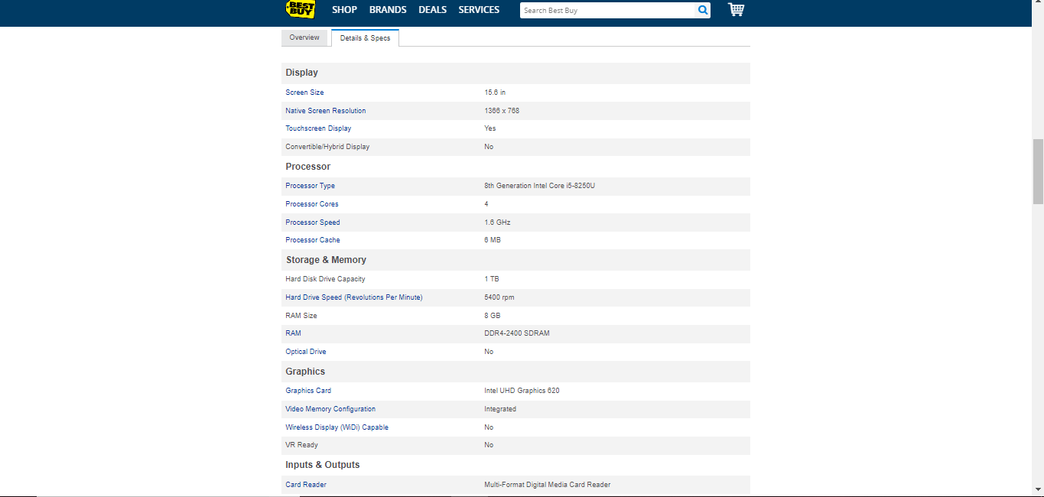

Second Source

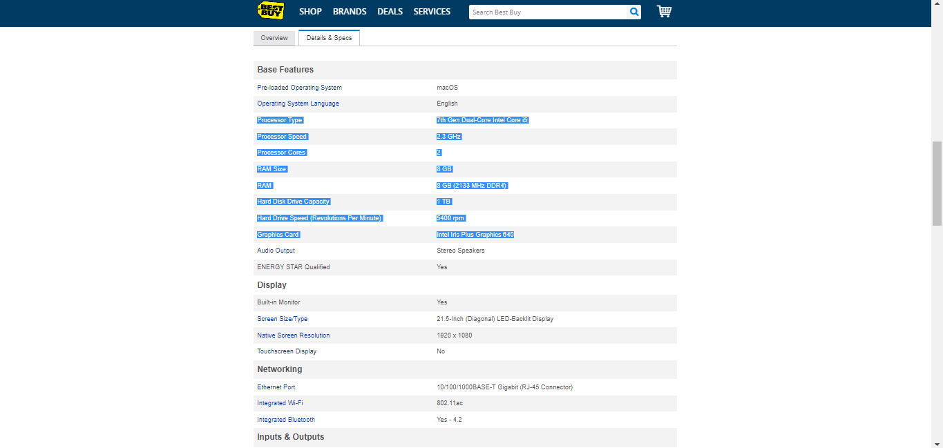

1. From both sources, there are only a few differences. The first source is a laptop and the other is a desktop computer. The CPU chip type, RAM, HDD and others like Network Interface are the same but, the CPU processor speed, the size, the graphics cards, audio, and others differ from each other. From both, the laptop fits my preferences the most.

Suggested on-line computer sources:

* [www.bestbuy.ca/](http://www.bestbuy.ca/)
* [www.dell.com/en-ca](http://www.dell.com/en-ca)
* [www.staples.ca](http://www.staples.ca)
* [www.tigerdirect.ca/](http://www.tigerdirect.ca/)
* [www.canadacomputers.com](http://www.canadacomputers.com)

**Level 4: Sharing Your Dream Machine**

1. Prepare a brochure documenting your dream machine options and choices.
   1. The target audience is other students in the class
   2. You should explain your target task (e.g. game computer) and how this affects configuration choices.
   3. You should explain your configuration choices in greater detail
   4. Your two purchase options should be explained and compared
2. Share your brochure
   1. By uploading it to your repository
   2. By presenting it during the in-class tradeshow (date TBD)
3. Visit and report on other trade show presentations / brochures
   1. Complete the Passport Template (TBD) as you participate in the in-class tradeshow.

**Task & Function Signup**

|  |  |
| --- | --- |
| **Task** | **Student Name** |
| ***Game Computer*** |  |
| **Photo Editing & Organization** |  |
| ***Business Office Computer*** |  |
| ***Student Home Computer*** |  |
| ***Factory Floor Computer*** |  |
| ***Media Production and Streaming Computer*** |  |
| ***Web Surfing Computer*** |  |
| ***Game Computer*** |  |
| **Photo Editing & Organization** |  |
| ***Business Office Computer*** |  |
| ***Student Home Computer*** |  |
| ***Factory Floor Computer*** |  |
| ***Media Production and Streaming Computer*** |  |
| ***Web Surfing Computer*** |  |
| ***Game Computer*** |  |
| **Photo Editing & Organization** |  |
| ***Business Office Computer*** |  |
| ***Student Home Computer*** |  |
| ***Factory Floor Computer*** |  |
| ***Media Production and Streaming Computer*** |  |
| ***Web Surfing Computer*** |  |
| ***Game Computer*** |  |
| **Photo Editing & Organization** |  |
| ***Business Office Computer*** |  |
| ***Student Home Computer*** |  |
| ***Factory Floor Computer*** |  |
| ***Media Production and Streaming Computer*** |  |
| ***Web Surfing Computer*** |  |
|  |  |
|  |  |